# Project 2 WAAD Images

## Preliminary: 10/15/18

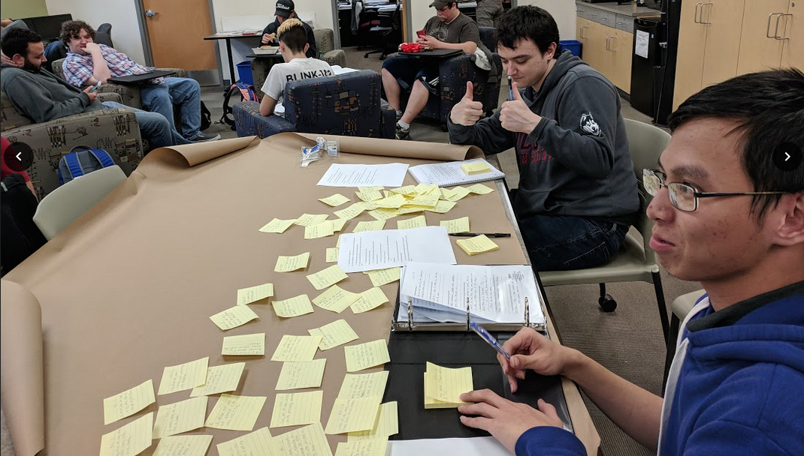

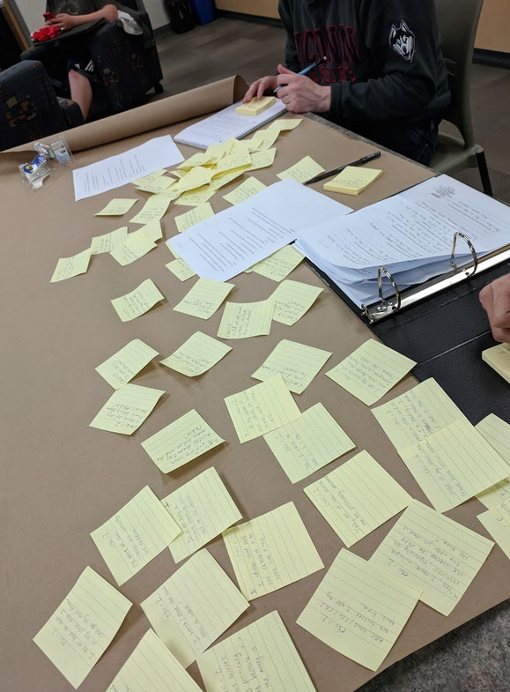

## Completed: 10/15/18

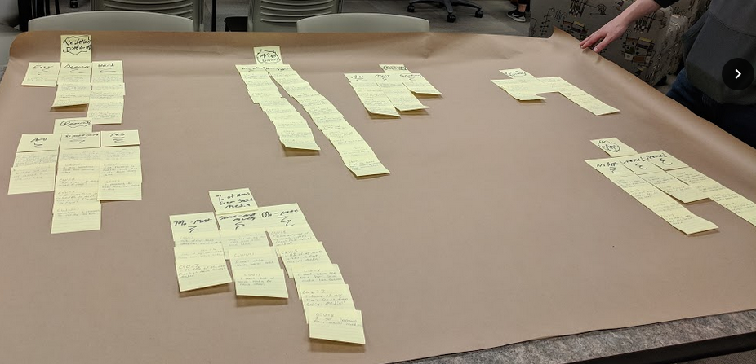

## By Sections: 10/15/18

